Art and Belief in the Middle Ages and Renaissance: A Mini-Colloquium

Speakers:
Trinita Kennedy, Associate Curator, Frist Center for the Visual Arts, Nashville
Theresa Flanigan, Assistant Professor, The College of St Rose, New York

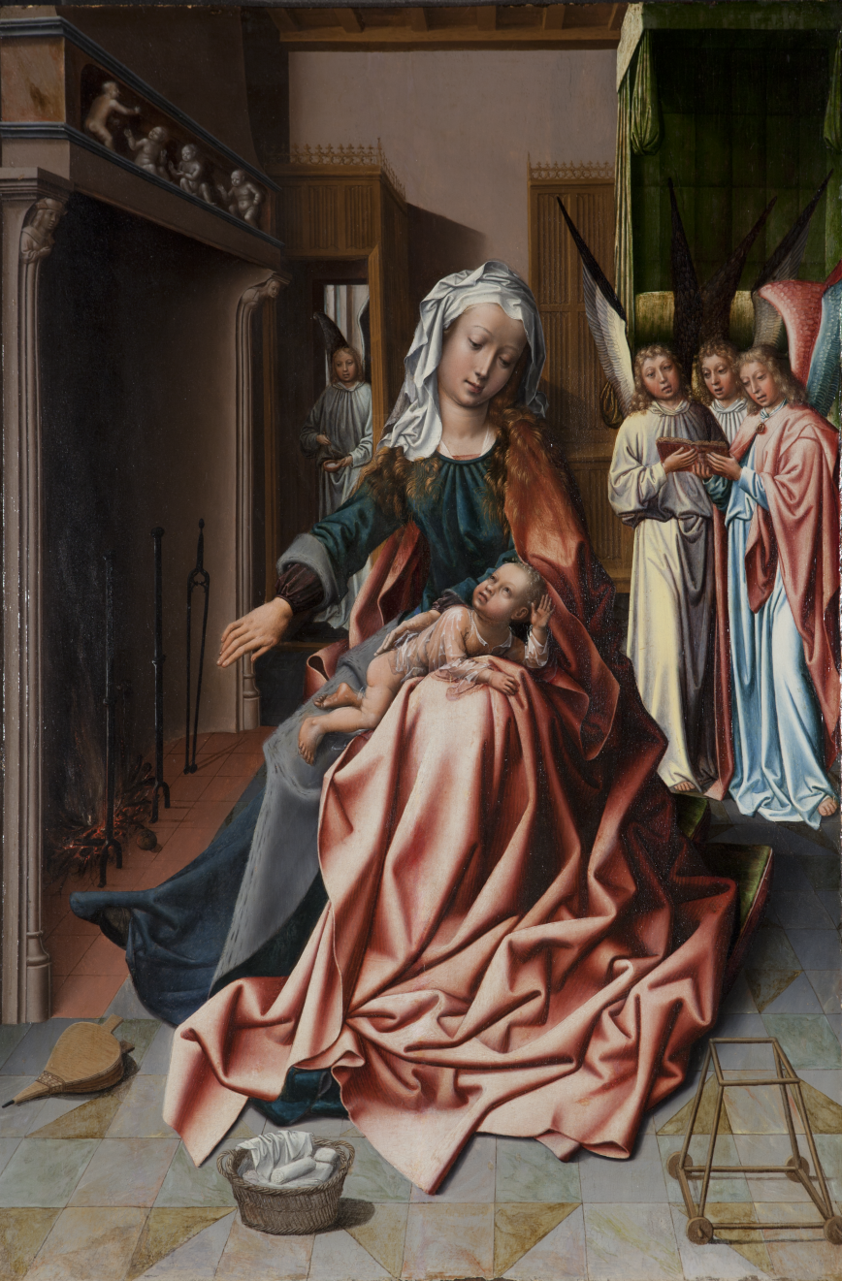

Thursday, March 22nd
2-4 pm
Woldenberg Art Center Room 209

Presented by the Newcomb Art Department and the Center for Scholars of the School of Liberal Arts

