An Undergraduate Workshop

PRINTS IN CONTEXT:
The Woodblock Image in Literary and Cultural History
in association with the Tamarind Touchstones: Fabulous at Fifty Exhibit, Celebrating Excellence in the Fine Art of Lithography

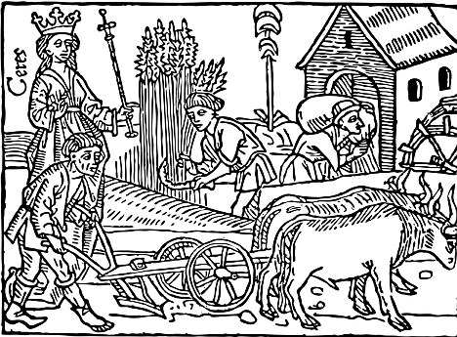

Professor Holly Flora, Art History
Professor Michael Kuczynski, English

Newcomb Art Gallery
Monday, April 2, 2012
3:00-4:00 p.m.

Refreshments following.

